FINAL PROJECT INTERIM REPORT


Alif Sathar

November 06, 2025

—

Developing Privacy-Preserving Artificial Intelligence-based Solutions for Healthcare or IoT

—

Professor Raj Shukla
—

BSc Artificial Intelligence



PROJECT PROPOSAL
The project focuses on developing a privacy-preserving Artificial Intelligence (AI) solution that can be applied to sensitive areas like healthcare or the Internet of Things (IoT). These are fields that use a lot of private and sensitive data, so it’s important to make sure that information stays secure while still training AI models effectively.

To achieve this, I plan to investigate and implement privacy-preserving techniques such as federated learning and differential privacy, Split Learning and Split-Fed Learning to see how they can help protect data. I’ll focus on using something like Split-Fed Learning for Healthcare Assets, where data doesn’t have to be shared directly between devices.

I plan to use Python and TensorFlow to build a small prototype model, test it on a suitable dataset, and check how well it performs when privacy-preserving methods are added. The main goal is to show that it’s possible to train AI models that give good results without exposing sensitive data.



THE PROCESS

HEADING FIVE

Phase | Task | Timeline | Deliverable
Week 1–3 | Conduct background research and literature review on privacy-preserving AI techniques like federated, Split and Split-Fed Learning. | Oct–Nov 2025 | Short summary of findings and references
Week 4–6 | Finalize project title, objectives, and confirm dataset (either healthcare or IoT data) | Nov–Dec 2025 | Defined project scope and selected dataset
Week 7–9 | System design and setup – plan architecture, tools, and frameworks (Python, TensorFlow) | Dec 2025 – Jan 2026 | Basic design diagram and development setup
Week 10–13 | Start model development – implement baseline AI model without privacy mechanisms | Jan–Feb 2026 | Early working version of model
Week 14–17 | Add privacy-preserving techniques (e.g., federated learning, differential privacy) and test performance | Feb–Mar 2026 | Updated model with privacy layer and initial results
Week 18–20 | Evaluation and testing – compare accuracy, efficiency, and privacy trade-offs | Mar–Apr 2026 | Evaluation report and test results
Week 21–22 | Final improvements, documentation, and prepare poster presentation | April 2026 | Final submission (Report & Poster) by 24 April 2026

Key Deadline Submissions:

- Poster Presentation: Early April
- Final Report: 24th April 2026

ETHICS CONFIRMATION

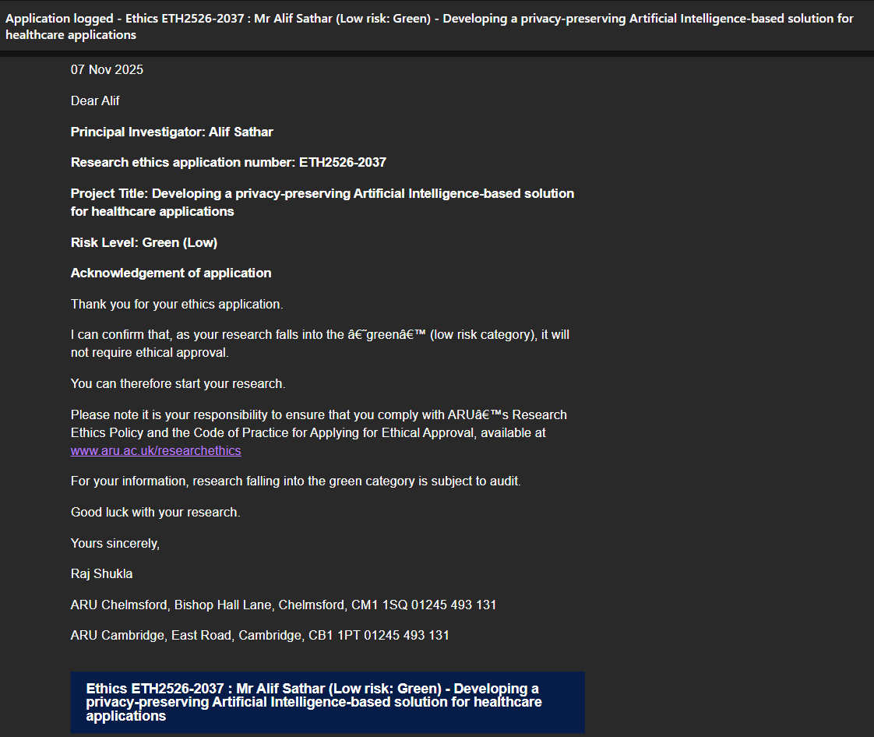

MY CV

After finishing my degree in Artificial Intelligence at Anglia Ruskin University, I want to build a career where I can apply what I’ve learned to solve real problems using AI. I’m especially interested in roles like Machine Learning Engineer or AI Developer, where I can work on projects involving automation, computer vision, or generative models.
I hope to start my career in a tech-driven company that values innovation and gives me space to keep learning — companies like NVIDIA, OpenAI, or Google DeepMind inspire me because of their work in shaping the future of AI.
In the long run, I plan to continue my education with a Master’s degree in AI or Data Science. My aim is to keep growing as an engineer and researcher, focusing on developing AI systems that are not just powerful but also ethical and beneficial to people.

EMPLOYABILITY ACTIVITIES

- A screen grab confirming I have attended at least one Employability Event, at the Week 5 Careers Fair.

